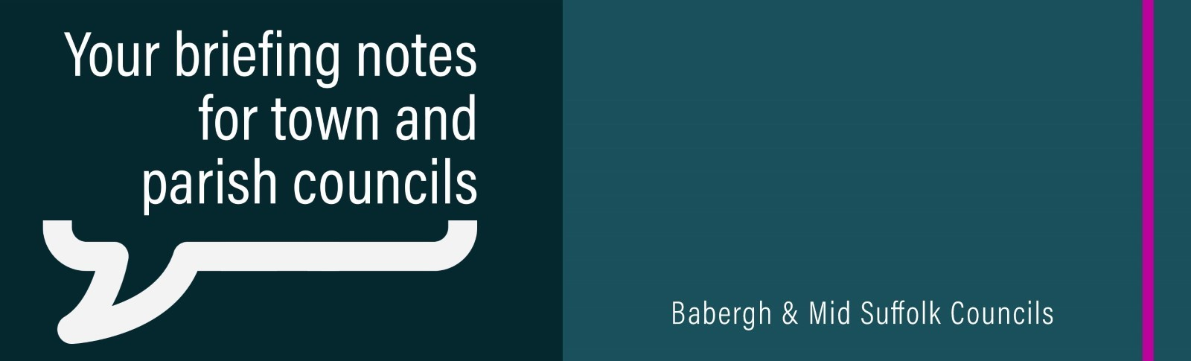

June 2023

Mid Suffolk’s new leader outlines initial priorities
Mid Suffolk District Council’s new leader has outlined the priorities for the new administration – refocusing the council’s work in a “greener and more sustainable direction” whilst tackling community issues. More information

The results are in: Local Elections 2023
There are new political landscapes for both Mid Suffolk District Council and Babergh District Council following the local elections. More information

Thousands raised by former Mid Suffolk Chairman for children’s charity
Former Mid Suffolk District Council Chairman, Cllr James Caston presented a cheque of £4,400 to Stowmarket ASD Saturday Clubs. More information

Congratulations to Their Majesties on Coronation Day
Babergh and Mid Suffolk District Councils Chairs sent congratulations on behalf of the districts to Their Majesties King Charles III and Queen Camilla on their coronation. More information

More than £500,000 goes back to communities in latest round of CIL funding
Money collected from developers in Mid Suffolk and Babergh is going back to the communities in our districts after councillors approved the latest round of Community Infrastructure Levy (CIL) bids. More information

Help for families during school holidays
Babergh and Mid Suffolk District Councils staged a range of activities to keep children and young people safe and active during half term and Easter holidays – also tackling holiday hunger. More information about half term activities and Easter activities

Making even more homes energy efficient
Over the next three years, more Suffolk homes will be upgraded to improve their energy efficiency, helping to reduce residents’ energy bills. More information

Residents urged to #ShakeItOut and keep recycling clean, dry and loose
A campaign encouraging people in Suffolk to shake out their plastic bags and not to put them in their recycling bins is underway. More information

Suffolk backs national campaign to tackle food waste
Suffolk Waste Partnership (SWP), which includes Babergh and Mid Suffolk District Councils, is backing a national campaign highlighting the problem of food waste and encouraging people to do something about it. More information

Free compost and cheap bins to help green fingered residents
Successful initiatives to help residents get composting, as part of International Compost Awareness Week. More information

Stowmarket opens a window of opportunity
Stowmarket’s high street could become a showcase for artists and creatives this summer with the launch of a pilot project to revitalise an empty shop window in the town. More information

Contractor appointed for 5a Cross Street, Eye
Plans to transform 5a Cross Street, Eye, are underway following the appointment of Colnesett Ltd. More information

Planning application submitted for Stowmarket sport, health & wellbeing, education, and leisure facilities
A full planning application for new Stowmarket sport, health & wellbeing, education, and leisure facilities has been submitted to Mid Suffolk District Council. More information

Schoolchildren and those living with dementia share memories
A project building empathy and understanding about dementia has come to a Mid Suffolk care home, with a local school visiting to hear about residents’ lives and experiences. More information

Former school transformed into much needed homes
Keys to 41 new affordable homes were handed over to Mid Suffolk District Council following the final stage of the transformation of the former Needham Market Middle School. More information

Plans for Skills and Innovation Centre at Gateway 14 unveiled
Local businesses, students and workers could all benefit from modern, collaborative working and learning spaces at Gateway 14, following the approval of an initial business case. More information

State-of-the-art emergency services hub opens in Stowmarket
A new police and fire station off Needham Road, Stowmarket, has opened, following a £431K contribution from Mid Suffolk District Council through the Community Infrastructure Levy. More information

25 BY 25: Suffolk's challenge to businesses to tackle the climate emergency
The launch of the ’25 by 25’ campaign sees Suffolk businesses urged to pledge a 25% reduction in their carbon emissions by 2025. More information

Bin lorry naming competition winners get behind the wheel of Ed Sheerbin
Babergh and Mid Suffolk’s bin lorry naming competition winners enjoyed the chance to get behind the wheel of ‘Ed Sheerbin’ and ‘Binnie the Pooh’. More information

