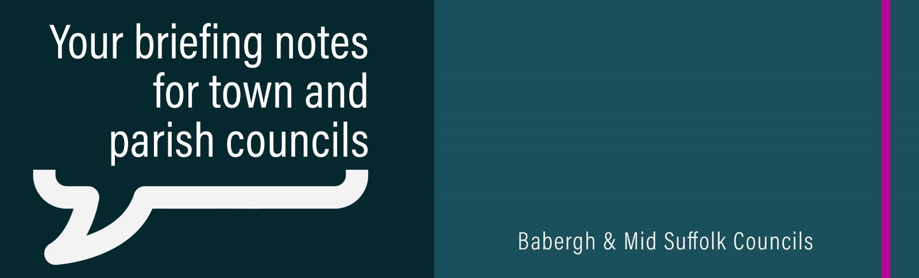
Mid Suffolk’s £3m funding for scheme to link villages – latest for ‘trailblazing’ network
Elmswell and Woolpit are to be connected by a new footpath and cycle way thanks to £3m of funding from Mid Suffolk District Council.

Council considers £1m grant for Food Museum to take ‘major leap forward’
The Food Museum in Stowmarket could receive a £1million boost from Mid Suffolk District Council for a major new project.

Last chance to complete our LGR survey
Our Local Government Reorganisation runs until 26 July. We are keen for as many people as possible to have their say, so please continue to share it with your networks and communities.

District and Borough Councils’ clear message to communities: “Let’s shape the future of Suffolk together!”
Suffolk’s five district and borough councils are launching a county-wide survey asking people for their views on the future of vital local government services. Make sure you take the survey yourself and share it with your community.

Let there be light... and heat!
Residents in Rattlesden can now look forward to an extra warm welcome – thanks to £33k of funding for a new heat and light chandelier system from Mid Suffolk District Council.

Pride in Your Place grant returns
Applications for Mid Suffolk District Council’s Pride in Your Place grant have reopened, offering funding to projects that bolster community pride and celebrate the heritage of towns and villages across the district.

Chance for motorists to have their say in Stowmarket car park review
Motorists are being invited to have their say on council-owned car parks in Stowmarket, ahead of a review later this year.

Thousands of listed building owners could benefit from innovative planning change
Thousands of listed building owners could find it easier to make windows more energy efficient under innovative proposals from Babergh and Mid Suffolk District Councils.

Stowmarket shop closed for selling illegal tobacco and vapes
A Suffolk store has been ordered to close for three months following a joint operation by Suffolk Trading Standards and Mid Suffolk District Council

Rentable electric cars arrive in Babergh and Mid Suffolk
Six electric vehicles have arrived at three locations across Babergh and Mid Suffolk for communities to use as part of the Plug In Suffolk Car Club.

Football club scores new stand after £100k awarded
Work to build a new stand at Needham Market Football Club’s stadium will soon be underway thanks to a £100,000 award from Mid Suffolk District Council.

‘Trek, treat, repeat’ – Beautiful walks and foodie gems celebrated in new project
Stunning walks and fantastic places to eat are showcased across Babergh and Mid Suffolk in a new initiative.

Public Switched Telephone Network
Landline phones are switching to digital, which could stop telecare alarms working.

This means that all landline providers need to know which of their customers use telecare, so they can keep them safe.

The switchover is already happening, so you need to act now. If you, a resident, or someone you know uses a telecare alarm, make sure to contact the landline provider for support. Visit the digital phone switchover website for more information.

Community Fun Days July 2025
Community Fun Days are returning to the districts at the end of July, providing families with a series of free days out packed full of activities. Events are taking place between 10am and 2pm at:

- Thurston, New Green – Thursday, 24 July
- Stowmarket, Recreation Ground – Monday, 28 July

Each event is free attend and has activities for all ages - people just need to turn up on the day. However, children that receive means tested free school meals are able to pre-book some activities and order a free lunch by visiting the Abbeycroft website - our partners for this year's fun days.

Feel Good Suffolk
The Feel Good Suffolk team will soon be delivering free weekly face-to-face sessions in Stowmarket, helping a dedicated group of smokers to kick the habit.
The sessions are free to attend, but spaces are limited. The group will be meeting at 6pm each Thursday in the garden room at Red Gables - and there's still time to sign up.
If you know of a resident in the Stowmarket area that would benefit from being part of the group, encourage them to email our health referrals mailbox to get involved.
Additionally, please continue to signpost Feel Good Suffolk to anyone looking to make a healthy change in their life. The website contains a wealth of free information and resources to help people prioritise their health and wellbeing.

Rural Housing Week event
Parishes across the districts are being invited to a Rural Housing Week event, hosted by Community Action Suffolk, from 10am to 3pm on 10 July at the John Peel Centre.

